IRLANDANDO 16-25 AGOSTO 2017

Interpreti : SIMONA DANIELA MARZIA
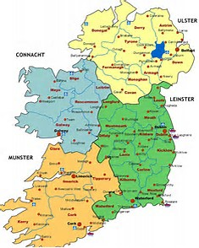

Bus da stazione centrale

Partenza: 16/8 Orio al Serio/Belfast International FR1378 H. 10.20/11.55

Bus 300/300A fino a Europa Bus Station, poi taxi (o taxi diretto dall’aeroporto ?)

HOTEL HARPERS – BELFAST check in 16/8 – check out 18/8

16 = bus turistico - Università – Ulster museum (?) – Donegal Square – City Hall - St. George’s market

Telefonare per fissare pick up con autonoleggio

17 = Titanic museum – Albert memorial clock – Royal Avenue – cattedrale S. Anna – Murales Shankill road

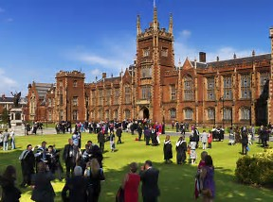
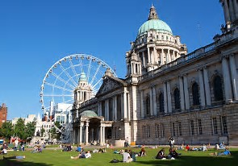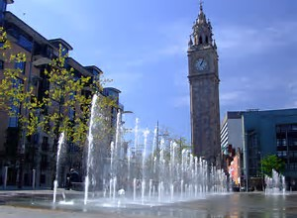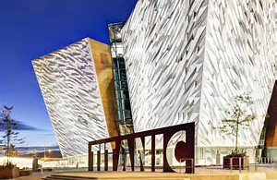

Noleggio auto – verso le 10

OPZIONE A

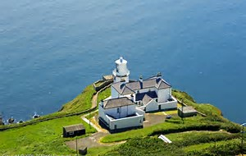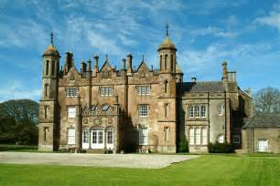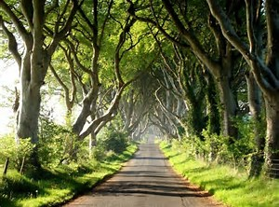

26 km Faro Blackhead 45’-1h
34 km Glenarm Castle 1h
(£ 6 - Mon – Sat: 10am – 5pm / Sun: 11am – 5pm) http://www.glenarmcastle.com/
62 km Dark Hedges, Ballymoney 1h10’
14 km Carrick-a-Rede Island – Ballintoy 20’
20 km Giant’s Causeway 20’
9 km Dunluce Castle 10’
10 km Portstewart 20’
(circa 175 km)

OPZIONE B

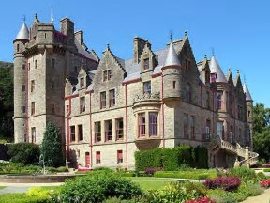

10 km Castello 30’
76 km Dark Hedges, Ballymoney 1h10’
14 km Carrick-a-Rede Island – Ballintoy 20’
20 km Giant’s Causeway 20’
9 km Dunluce Castle 10’
10 km Portstewart 20’
(circa 139 km)

CALIFORNIA LODGE – PORTSTEWART check in 18/8 – check out 19/8

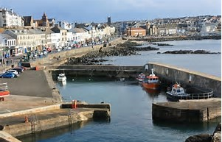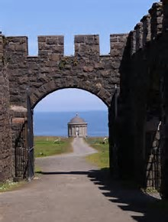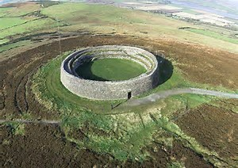

OPZIONE A

20 km Musenden temple 35’
12 km + traghetto - Greencastle Inishowen museum (€ 5/4 - Monday/Saturday 9.30-17.30 - Sunday 12-17.30pm
40 km Malin Head 1h

OPZIONE B

20 km Musenden temple 35’
106 km Malin Head 2h 15’ ???
57 km Grianan of Aileach (forte in pietra) 1h 15’
8 km Derry

OPZIONE C

20 km Musenden temple 35’
44 km Londoderry 1h

TROY HALL – LONDONDERRY check in 19/8 – check out 20/8

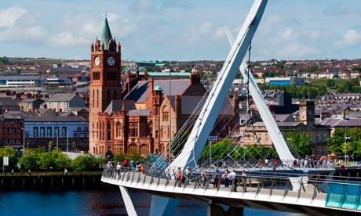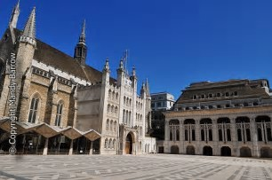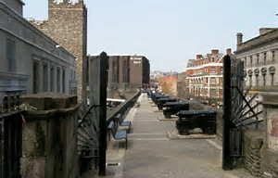

Mura – murales – S. Columb’s cathedral – Guildhall – Peace Bridge – (Craft village) – St. Eugene’s cathedral

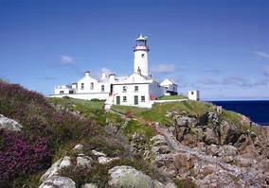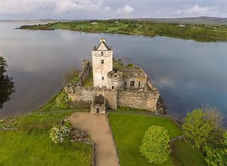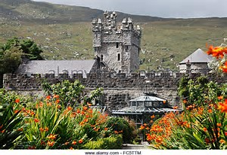

80 km - Fanad Head Lighthouse – aperto ogni giorno h. 10–18 € 8/5 1h 45’
??? 23 km Doe Castle (Daily from 9am - 6pm) FREE
42 km Glenveagh National Park 1H
(Visitors Centre open 9.15-17.30 - last bus to castle and garden
is at 16.45 - last bus return from the castle is at 17.45)
Bus €3 – castello €7
62 km Donegal 1h 10’
(circa 180 km)

ARD NA BREATHA BOUTIQUE GUESTHOUSE DONEGAL check in 20/8 – check out 21/8

The Diamond, piazza centrale
Castello (Daily, 10:00 - 18:00) € 5
50 km Slieve League (scogliere) 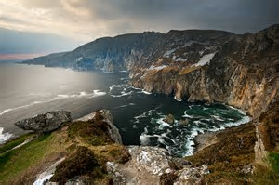 1h
80 km Ballyshannon - Tullan strand 1h 40’
20 km Cassiebawn castle 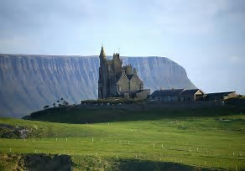 solo esterno 30’
27 km Sligo 30’
(circa 177 km)

RIVERSIDE HOTEL – SLIGO check in 21/8 – check out 22/8

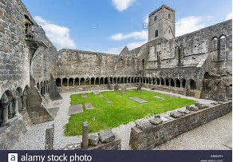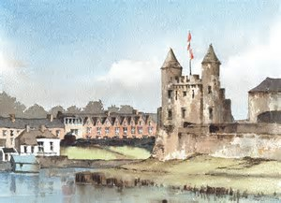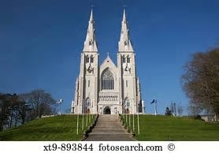

Abbey (€5 - Daily 10.00-18.00)
70 km Enniskillen Castle 1h 15’
(Lunedi-Venerdì 9:30-17 - sabato 11-17 - domenica 11-17 - £ 5)
80 km Armagh – cattedrale S. Patrizio 1h 30’
42 km Warrenpoint 1h
(circa 170 km)

THE LOUGH AND QUAY – WARRENPOINT check in 22/8 – check out 23/8

Narrow Water Castle 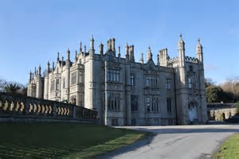
12 km NEWRY – cattedrale 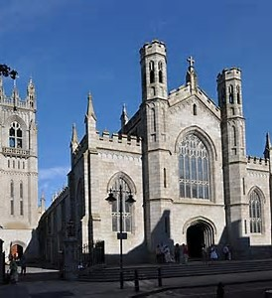 15’
65 km KNOWTH, DOWTH, NEWGRANGE 50’
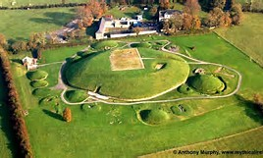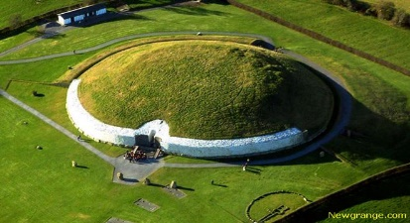
12 km Drogheda 20’
(circa 90 km)

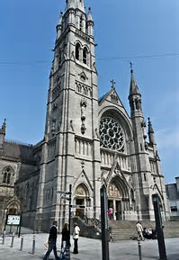

WESTCOURT HOTEL – DROGHEDA check in 23/8 – check out 24/8

(Howth)
41 km – SWORDS aeroporto 35’

RESTITUZIONE AUTO
AIRLINK EXPRESS DA AEROPORTO A CITTA’ – biglietto a/r € 12,00

ARLINGTON HOTEL O'CONNELL BRIDGE DUBLINO check in 24/8 – check out 25/8

Bus turistico – Trinity College – Temple bar -

Ritorno 25/8 giov. Dublino/Malpensa EI436 H. 17.50/21.20
Treno Malpensa-Milano Cadorna
Taxi

